Handbook for Sales Price Upload(xxsopcld.p)
- Program name : xxsopcld.p
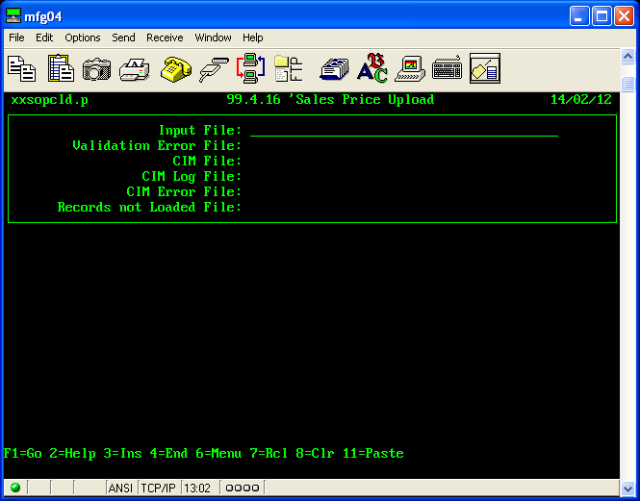

- Template for upload
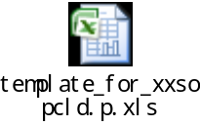

- User can download existing sales price from 1.24 'Customer Item Price Extract(xxcuptrp.p).
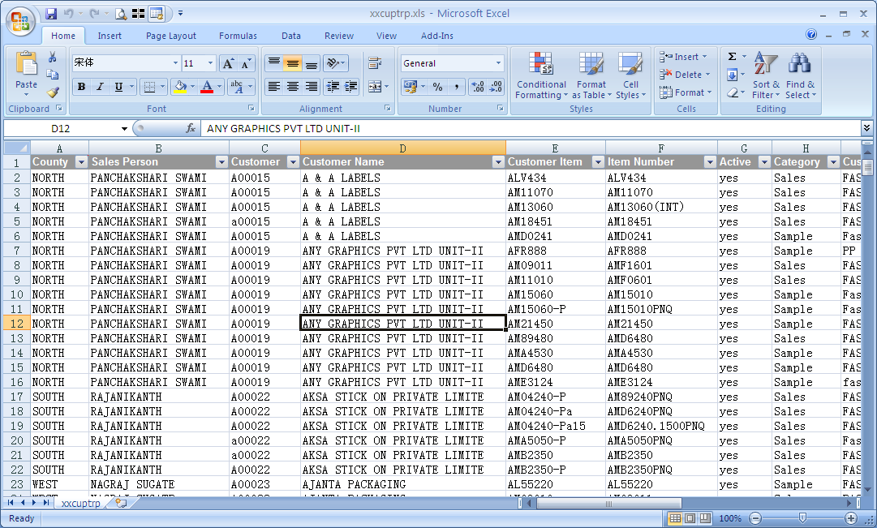
3.1 Delete column Q to Column Y
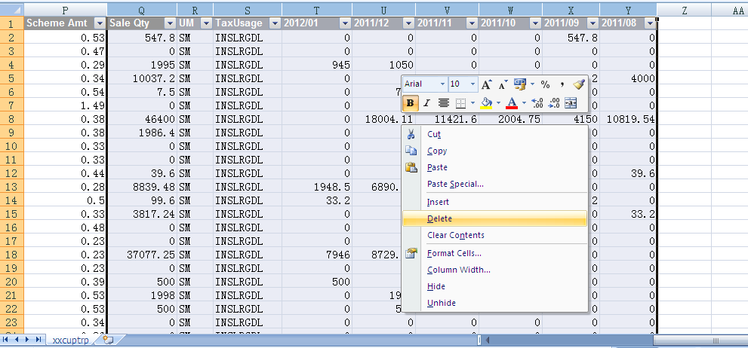
  - Filter data in excel sheet, delete those lines which price is not going be updated.
  - Add new column Q to input reason for price modification.
  - Change price in excel sheet.

  - Highlight those lines you want to upload to mfg/pro with yellow color.
NOTE: ONLY HIGHLIGHTED LINES WILL BE UPLOADED.
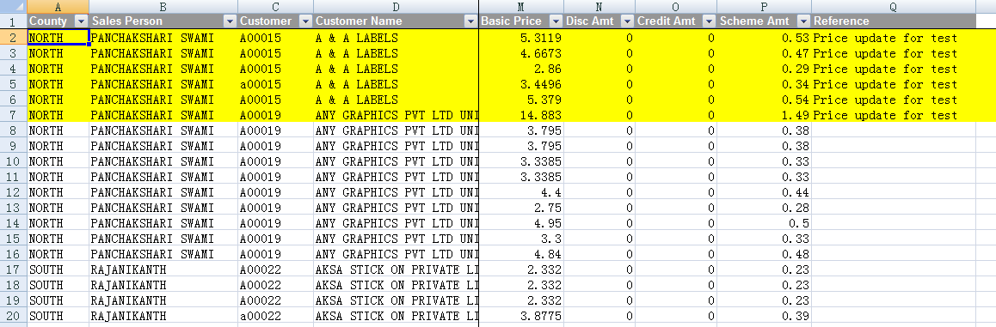
  - Open Macro file.
You can find more setup in this Macro file at each field comments.
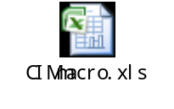
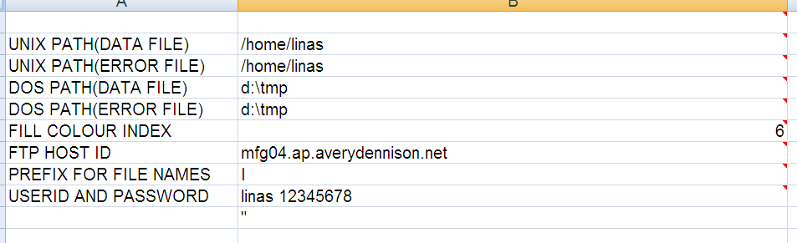

  - Go back to uploading excel file.
Select View → View Macros → putdatafile
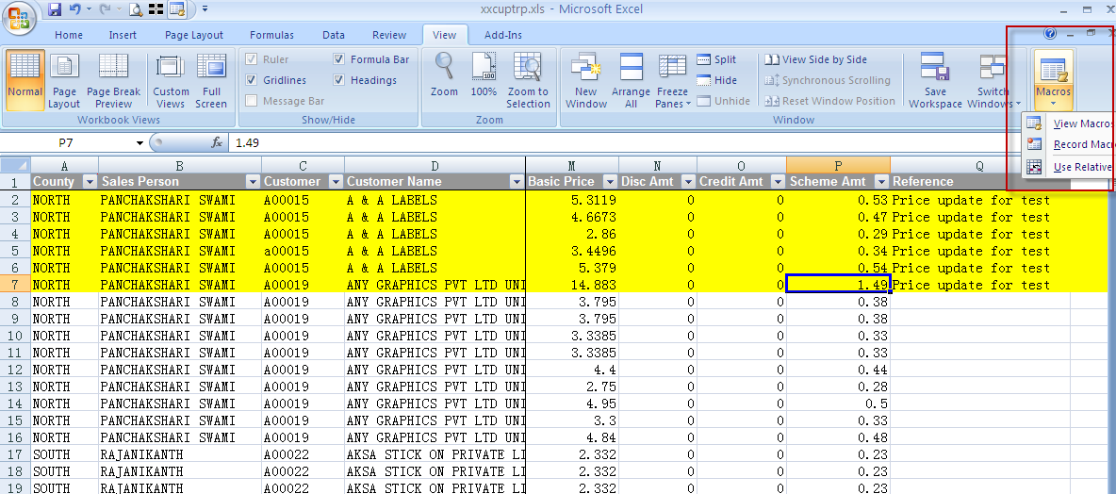
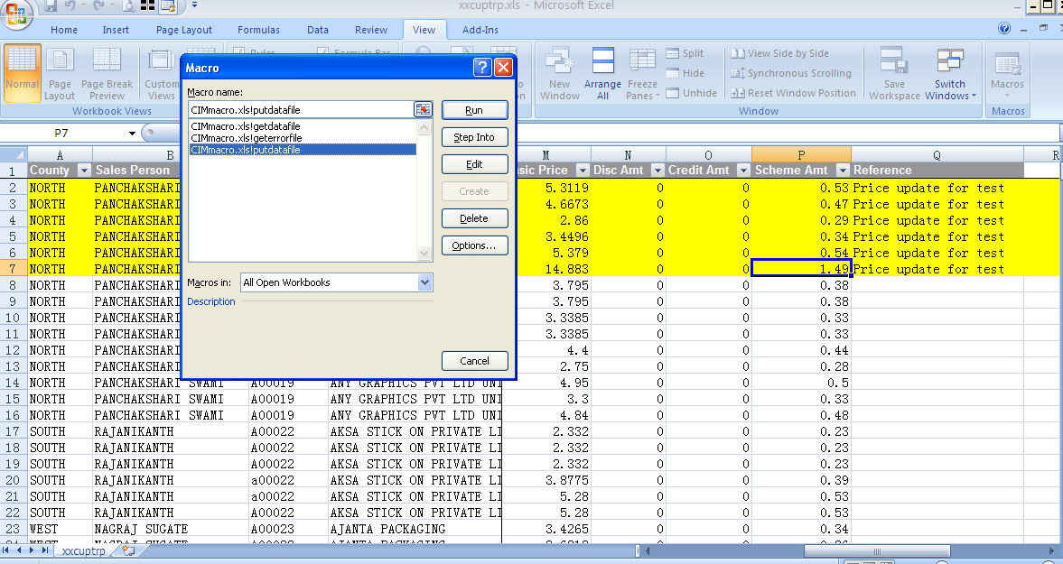
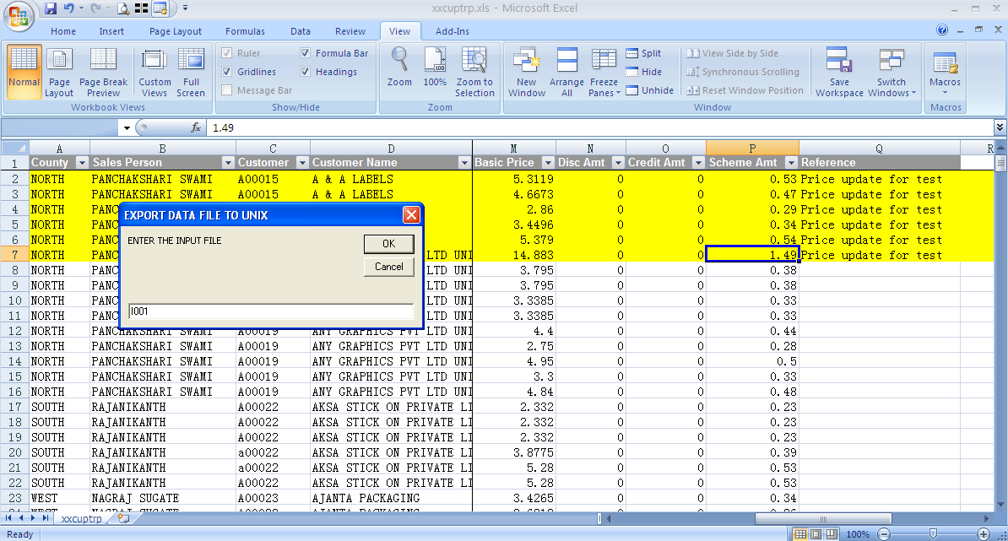
Enter the name of csv file, and the prefix should be same with setup in Macro.xls.
- Go to mfg/pro and run xxsopcld.p
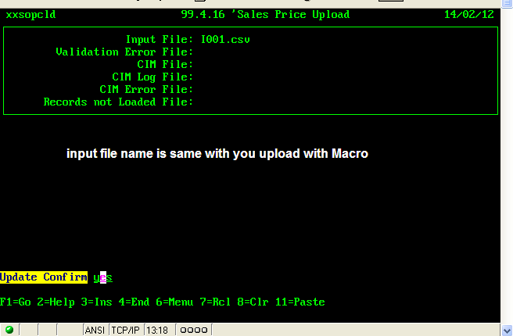
- If there is message “Please Check Validation Error File”, then you need validate the data again.
It will not excute upload until the validation is ok.
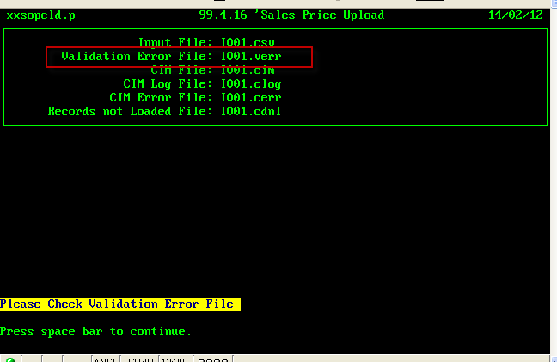

- You can download the validation error file with cimmacro tool either.
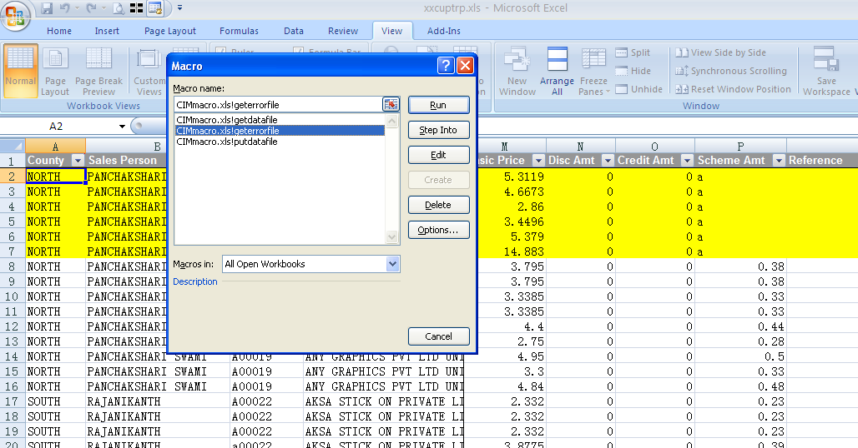
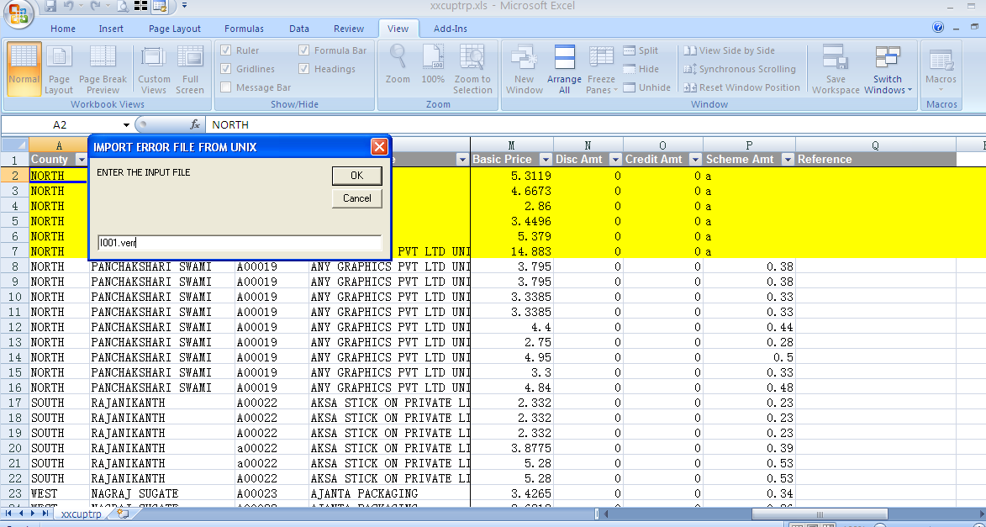
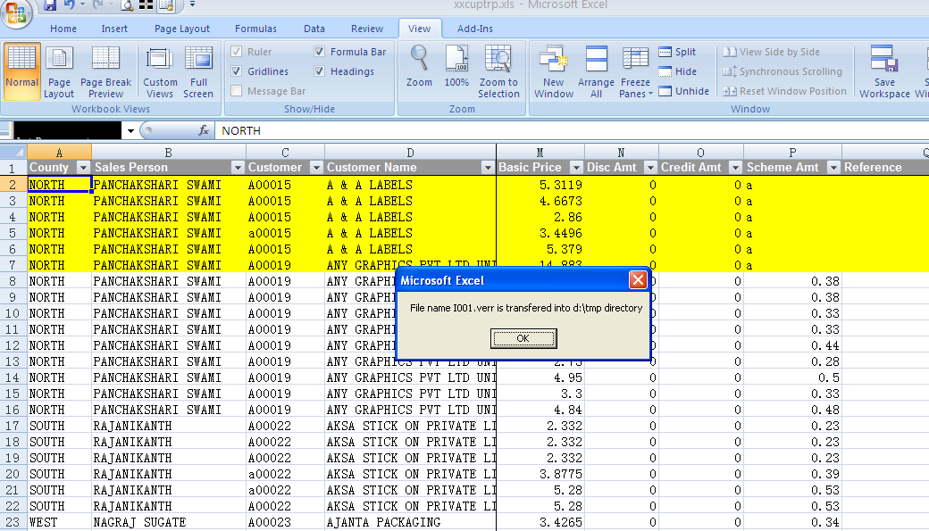
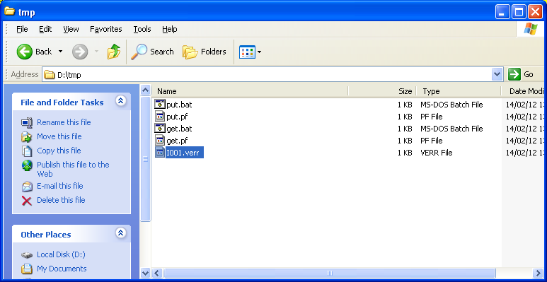
Open it with notepad.

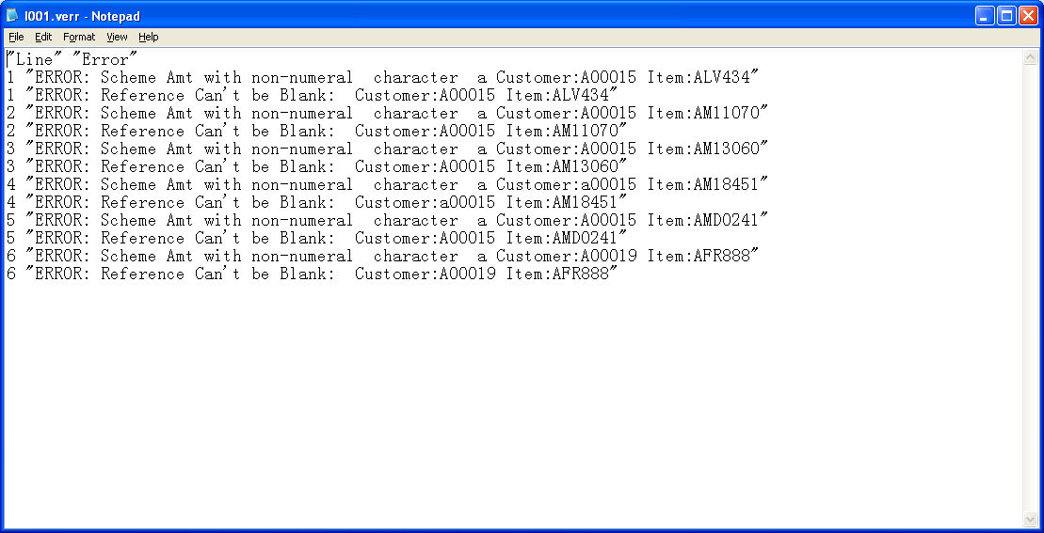
Adjust the excel sheet according to the error message and upload again.

- If all validation is ok, there will be massage like “TOTAL RECORDS TO BE LOADED:”
